(Pl. Expand all initials) | First Name |  |  | Middle |  |  |  |  | Last
Name:
Occupation: |  |  |  |  |  | Title: Mr. , Mrs. , Ms. , Dr.
Designation:
Date of birth: dd/mm/yyyy |  |  |  |  |  | Sex: Male , Female
Name of Institution and Address:
Office Phone: (w. ISD / STD code) |  |  |  |  | Fax:
Mobile 1: |  |  |  |  | Mobile 2:
Email: |  |  |  |  | I have attached my photo: jpg , tif , psd
Home/office address other than above if you prefer for correspondence
Species of special interest in aquatic (marine) invertebrates | List order and family  1.  2.  3.
Are you interested in: | Taxonomy , Diversity , Trade , Ecology , Economics , Aquaculture , Photography , Education , Others
Are you a Ph.D. holder? | Yes , No , Presently enrolled for a Ph.D.
Is your Ph.D. on: | Marine biology/conservation , Laboratory studies , Ecology , Others (explain briefly)
Title of Ph.D. Dissertation and University:
Please tick Yes or No
Have you taken any formal or informal training in the techniques needed to study Marine invertebrates ? Yes No
Would you be interested in taking a short term training eg. taxonomy ? Yes No
Please list your field projects in aquatic (marine) invertebrates (If published please list in publications details).
In case there are more than 5 studies please include then under More Information:
Short title of study |  |  | Geographical area of study |  |  |  |  | Dates of study, (not publication)
On going or completed projects related to marine invertebrates (eg. DST, CSIR, UGC, etc.) |  |  | Geographical area of study/work |  |  |  |  | Dates of study or work, not publication. (If published please list under Publications).
Publication (relevant to marine invertebrate studies only):
Please list ALL your publication relevant to aquatic (marine) invertebrate studies for complete listing in the directory and on the web also please enclose a copy of your recent (within the last two years) publications.
Any other information you wish to share:
Names, address and /or email address of other marine invertebrate field biologist, specialist, amateurs, students or educators that you wish to suggest we contact:
Co-Chairs: Dr. B.A. Daniel and Dr. Ramanibai R.
Aquatic (Marine) Invertebrate Conservation Network of South Asia
Please send the filled-in form by Email to: badaniel@zooreach.org

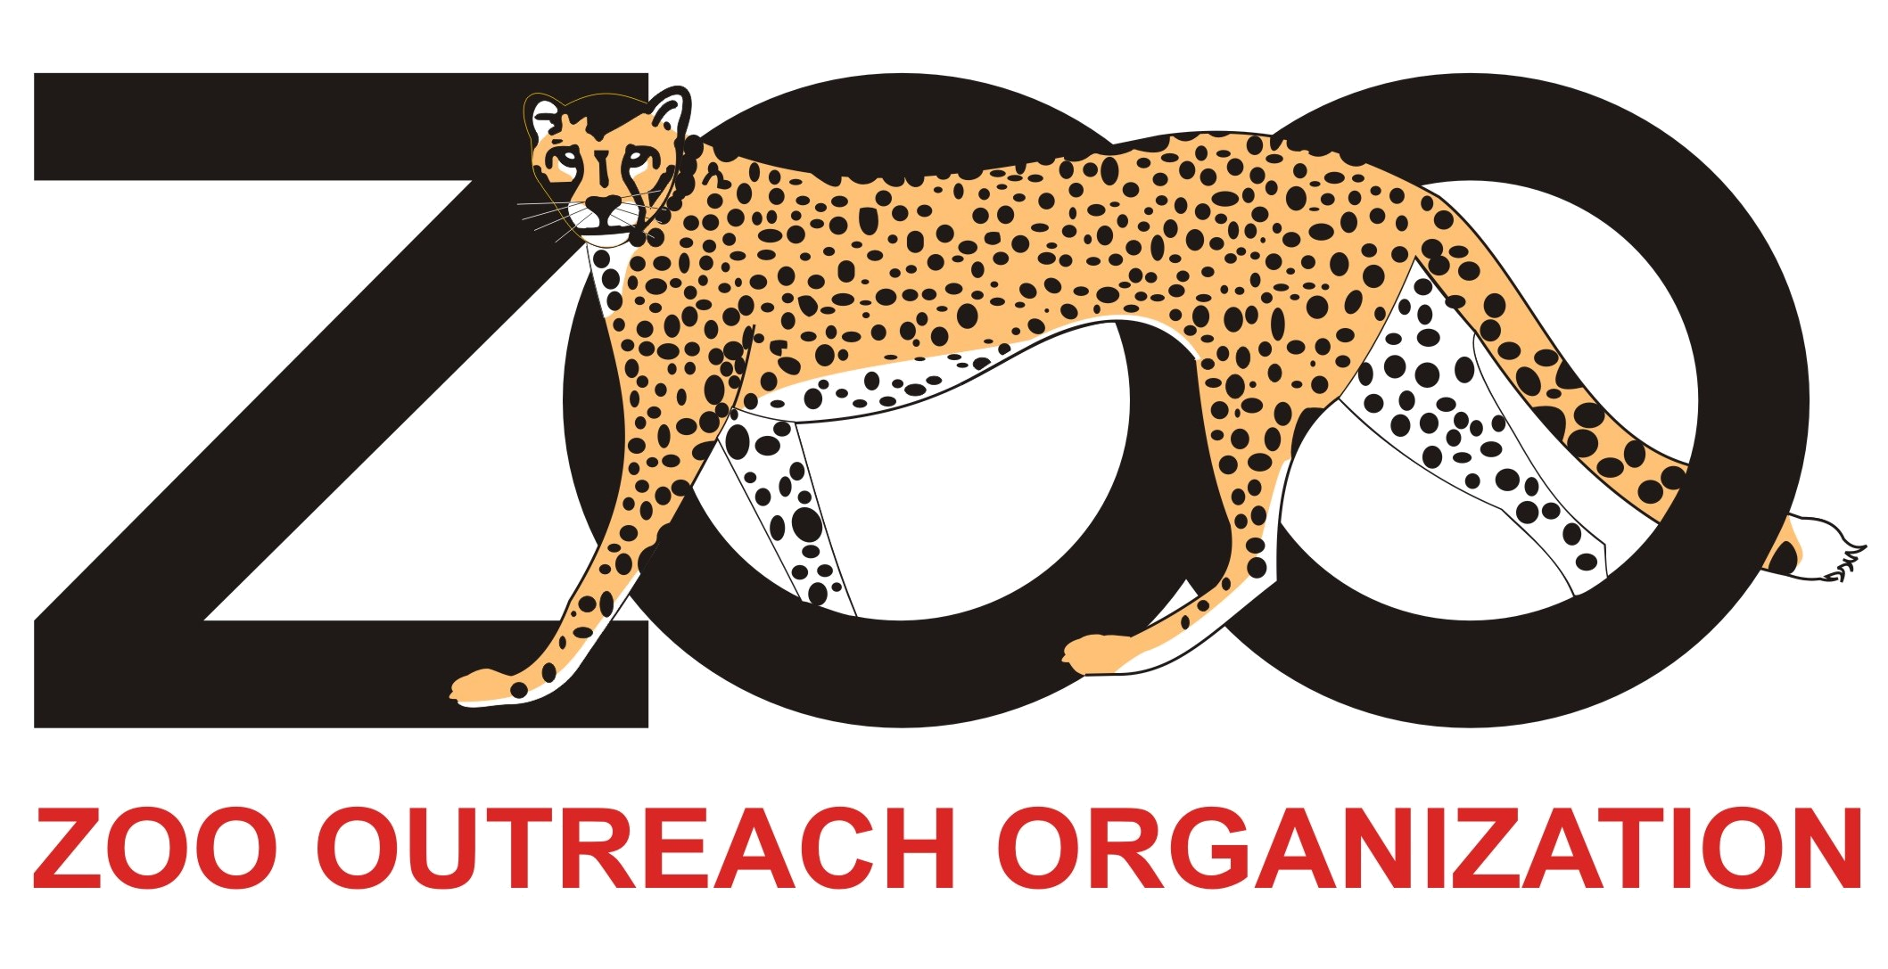
Zoo Outreach Organization, CPSG South Asia
12, Thiruvannamalai Nagar, Saravanampatti, Coimbatore, Tamil Nadu 641 035, India
Websites: www.zooreach.org/Networks/Invertebrate/SAsISG.htm#three
REMEMBER to attach your passport size photograph to be incorporated in the directory
Please send a separate JPEG file as attachment

